MANUSCRIPT TEMPLATE
TITLE OF THE ARTICLE WRITTEN IN BOLD CAPITAL LETTERS, FONT SIZE 14 | FACTORS INFLUENCING STUDENTS' DECISIONS TO CHOOSE KIEN GIANG COLLEGE
Author information in Vietnamese: If there is only one author:  Author's full name (lowercase, bold)  Department, Institution, Country (lowercase, italic)  Corresponding author: Full name, Email (lowercase, italic) | Van A Nguyen  Department of Economics, Dong Thap University, Vietnam  Corresponding author: Van A Nguyen, Email: nva@dthu.edu.vn
Authors’ information in Vietnamese: If there are two or more authors  Author's full name^{1*}, Author's full name¹ and Author's full name² (lowercase, bold)  ¹Department, Institution, Country (lowercase, italic)  ²Department, Institution, Country (lowercase, italic)  *Corresponding author: Full name, Email (lowercase, italic) | Van A Nguyen^{1*}, Van B Pham¹, and Van C Tran²  ¹Department of Economics, Dong Thap University, Vietnam  ²Department of Economics, An Giang University, Ho Chi Minh City National University, Vietnam  *Corresponding author: Van A Nguyen, Email: nva@dthu.edu.vn
Abstract  The abstract effectively conveys the research content and key findings of the article. The structure includes the following contents: Objectives, methods, and research results.  Should not exceed 300 words, font size 12, italicized.  Keywords: From 3 to 6 keywords, capitalize the first letter, arrange alphabetically, separate keywords by commas (,), italicize. | Abstract  The purpose of this study is to analyze the factors influencing students' decisions to choose Kiên Giang College. Data were collected from 481 students currently enrolled at Kiên Giang College. Descriptive statistical methods, assessment of scale reliability, exploratory factor analysis, and multiple linear regression analysis were used to analyze the data. The results indicate that there are eight factors influencing students' decisions to choose Kiên Giang College, including: the reputation of the institution, curriculum, support policies and transfer opportunities, employment opportunities, facilities, communication, extracurricular activities, and cost. The findings of this study provide a basis for the institution to develop directions and solutions to enhance the quality of service and admission activities in the future.  Keywords: College selection decision, students, Kien Giang College.
Article content | The content of the article must be composed using Microsoft Word, with A4 paper size, left margin of 3 cm, right margin of 2 cm, top margin of 2 cm, and bottom margin of 2 cm. The draft should not exceed fifteen (15) pages, including tables, figures, references, and appendices (if any).  The content section of the draft should use Unicode encoding, Times New Roman font, size 12, single spacing, 6pt spacing after and before each paragraph. The first line of each paragraph should be indented by 1 tab, which equals 1.27 cm. Both margins should be justified. Please select the 'Content' style to format the content section of the article as needed.
1. Introduction (lowercase, bold)
2. Literature review, research history, and hypothetical development (if any) (lowercase, bold)
3. Data (or materials) and research methods (lowercase, bold)
4. Results and discussion (lowercase, bold)
4.1. Subsection level 2 (lowercase, bold)
4.1.1. Subsection level 3 (lowercase, italic)
a. Subsection level 4 (lowercase, italic)
Table 1. The title of the table is placed at the top of the table, lowercase, bold, centered.
Column 1 | Column 2 | Column 3
Row 1 | 1 | 2
Row 2 | 3 | 4
Row 3 | 5 | 6
Note: The footnote (if any) must be placed at the end of the table, font size 11, justified on both sides, and should be a single line inseparable from the table.
Source: Citation is required when necessary. (Example: Tran & al. (2015).)
The text "Tất cả các hình vẽ, hình chụp, hộp, sơ đồ, biểu đồ, bản đồ, lưu đồ, thuật toán (không phải mã giả)... phải được gọi chung là hình, được canh giữa và đặt ở vị trí ngay sau phần nội dung đề cập đến chúng" can be translated into English as:

All drawings, photographs, boxes, diagrams, charts, maps, flowcharts, algorithms (excluding pseudocode)... must be collectively referred to as figures, centered, and placed immediately after the content section referring to them.
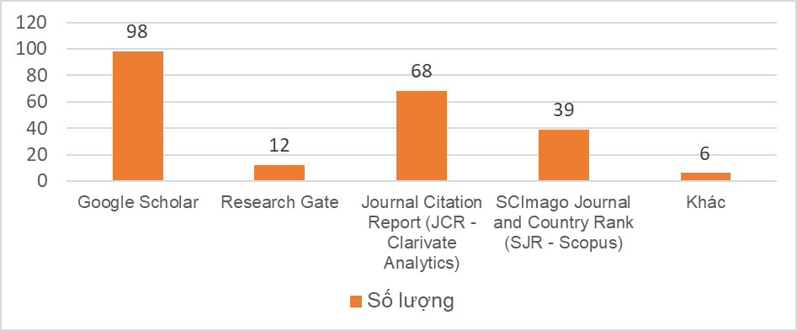
Figure 1. The title of the figure must be placed below the figure.
Source: Citations are required when necessary. For example: Nguyễn & al. (2015).
Formulas must be composed using the Insert/Object/Microsoft Equation 3.0 function in Microsoft Word (or auxiliary software with similar features such as MathType), and punctuation marks (period (.); comma (,); semicolon (;)) after the formulas must be placed immediately afterwards within the formula. Formulas are sequentially numbered, and these numbers must be right-aligned and properly cross-referenced in the text, for example: '... substituting formula (1) into formula (3), we have the general formula (4) as follows...'. Below is a useful suggestion for authors to refer to.
5. Conclusion and Policy Implications (if applicable)
Acknowledgments (if applicable): The content of the acknowledgment should be brief, within 2 to 3 lines, mentioning organizations, individuals who sponsored the funding, facilitated the research, or supported the study.
References  - Regulations for reference document listing and citation according to APA format.  - Only documents cited in the article are included in the reference list.  - Each list must contain at least 10 reference documents.  - The order of reference documents is arranged alphabetically (by author's surname), not numbered.  - Reference documents with more than 2 authors are connected by "&".  - When a document has three or more authors, only the first author is mentioned, followed by "& et al." | Link: https://apastyle.apa.org/style-grammar-guidelines/references
Book: Surname, Initials. (Year of publication). Title of the book (in italics). Place of publication: Publisher. | Jackson, L. M. (2019). The psychology of prejudice: From attitudes to social action (2nd ed.). American Psychological Association. https://doi.org/10.1037/0000168-000  Parenthetical citations: Research is defined as…(Jackson, 2019)  Narrative citations: Jackson (2019) stated that …  Note: If a work has two authors, separate their names with an ampersand (&) in a parenthetical citation or “and” in a narrative citation. If there are three or more authors, only include the first author’s last name followed by “et al.”, meaning “and others”.  Two authors  Parenthetical citations: (Harris & Cook, 2020)  Narrative citations: Harris and Cook (2020)  Three or more authors  Parenthetical citations: (Harris et al., 2020)  Narrative citations: Harris et al. (2020)
Edited book: Surname, Initials (Editor). (Year). Title of the Book (in italics). Place of Publication: Publisher. | Use the abbreviation “(Ed.)” for one editor and the abbreviation “(Eds.)” for multiple editors after the editor names, followed by a period.  Parenthetical citations: (Hygum & Pedersen, 2010; Kesharwani, 2020; Torino et al., 2019)  Narrative citations: Hygum and Pedersen (2010), Kesharwani (2020), and Torino et al. (2019)
Translated book:  Surname, First Name Initials. (Year). Title of the Book (in italics) (Translator, Translation). Place of Publication: Publisher. (Original publication date). | Watson, J. B., & Rayner, R. (2013). Conditioned emotional reactions: The case of Little Albert (D. Webb, Translator). CreateSpace Independent Publishing Platform. http://a.co/06Se6Na (Original work published 1920)  Parenthetical citation: (Watson & Rayner, 1920/2013)  Narrative citation: Watson and Rayner (1920/2013)
Several volumes of a multivolume work  Surname, Initials, and First Name. (Year of publication). Title of the Book (in italics) (Volume number). Place of Publication: Publisher. | Harris, K. R., Graham, S., & Urdan T. (2012). APA educational psychology handbook (Vols. 1–3). American Psychological Association.  Parenthetical citation: (Harris et al., 2012)  Narrative citation: Harris et al. (2012)
Chapter in an edited book  Surname, Initials, and First Name. (Year of publication). Title of the Chapter. In Editor's Last Name (Editor), Title of the Book (in italics) (chapter page number). Place of Publication: Publisher. | Dillard, J. P. (2020). Currents in the study of persuasion. In M. B. Oliver, A. A. Raney, & J. Bryant (Eds.), Media effects: Advances in theory and research (pp. 115–129). Routledge.  Parenthetical citation: (Dillard, 2020)  Narrative citation: Dillard (2020)
Journal article  Surname, Initials, and First Name. (Year of publication). Title of the Article. Journal Name (in italics), Volume(number), page range. Document identifier [DOI] (if available). | Grady, J. S., Her, M., Moreno, G., Perez, C., & Yelinek, J. (2019). Emotions in storybooks: A comparison of storybooks that represent ethnic and racial groups in the United States. Psychology of Popular Media Culture, 8(3), 207–217. https://doi.org/10.1037/ppm0000185  Parenthetical citation: (Grady et al., 2019)  Narrative citation: Grady et al. (2019)
Report  Surname, Initials, and First Name. (Year of publication). Title of the report (in italics) (Report number). Place of Publication: Publisher. | National Cancer Institute. (2019). Taking time: Support for people with cancer (NIH Publication No. 18-2059). U.S. Department of Health and Human Services, National Institutes of Health. https://www.cancer.gov/publications/patient-education/takingtime.pdf  Parenthetical citation: (National Cancer Institute, 2019)  Narrative citation: National Cancer Institute (2019)
Newspaper Article  Surname, Initials, and First Name. (Publication date: day, month, year). Title of the article. Newspaper Name (in italics), (issue), pp. page range. | Lyons, D. (2009, June 15). Don’t ‘iTune’ us: It’s geeks versus writers. Guess who’s winning. Newsweek, 153(24), 27-37.  Parenthetical citation: (Lyons, 2009)  Narrative citation: Lyons (2009)
Online Newspaper Article  Surname, Initials, and First Name. (Published date: day ... month ... year). Title of the article. Newspaper Name (in italics). Retrieved from http://xxx.xxx.com | Carey, B. (2019, March 22). Can we get better at forgetting? The New York Times. https://www.nytimes.com/2019/03/22/health/memory-forgetting-psychology.html  Parenthetical citation: (Carey, 2019)  Narrative citation: Carey (2019)
Dissertation or Thesis  Surname, Initials, and First Name. (Year of publication). Title of thesis/dissertation (in italics). University Name..., Vietnam. Retrieved from http://www.xxxxxx.com (if available). | Miranda, C. (2019). Exploring the lived experiences of foster youth who obtained graduate level degrees: Self-efficacy, resilience, and the impact on identity development. Pepperdine University, The UK.  Parenthetical citation: (Miranda, 2019)  Narrative citation: Miranda (2019)

